HYDROMAXX

GENERAL WARRANTY

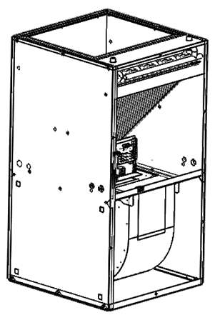
Hydromaxx, subject to the limitations described in this General Warranty, warrants that each appliance produced by Hydromaxx is, under normal operating conditions, free of defect in material and workmanship for a specific period of time from the date of original installation (as described in the “Summary of Warranty Programs” section below).

This warranty covers the appliance only and does not include labour costs, freight costs or other indirect expenses related to routine maintenance or the replacement of parts. If a part fails during the applicable warranty period, Hydromaxx will provide, at its sole discretion, a new or re-manufactured part to replace the defective part at no charge. Alternatively, and at its sole discretion, Hydromaxx will allow a credit in the amount of the then factory price for a new equivalent part toward the retail purchase price of a new Hydromaxx product.

SUMMARY OF WARRANTY PROGRAM

Hydromaxx Hydronic Air Handler Model Numbers

Hydromaxx-VHB504A, VHS504A, VRB504A, VRS504A

Parts- 5 years

Hydronic coil- 2 years from manufacture date,18 months after installation date.

A) Consumable Items: This warranty does not apply to materials which must be replaced in the course of routine maintenance.

B) Corrosive Atmosphere: The operation of the unit in the presence of corrosive elements such as acids, chlorine, fluorine or other damaging chemicals voids this warranty.

C) External Factors: This warranty does not apply to damages to the product caused by misuse, failure to provide proper maintenance, accidents, Acts of God or inadequate electrical supply.

D) Unauthorized Alteration: Unauthorized alteration or repair of the appliance affecting product reliability or performance voids this warranty.

E) Installation by a qualified person: The product must be installed by a qualified trades person in accordance with Hydromaxx installation instructions, applicable local and national codes, the industry standards and those of professional organizations such as the Heating, Refrigeration and Air Conditioning Institute of Canada and the Air Conditioning Contractors of America. Failure to do so voids this warranty.

F) Unauthorized Installation of Accessory Equipment: Hydromaxx authorizes the application of accessory equipment which will operate in conjunction with its products provided that the following conditions are met:

i.) The function or performance of the Hydromaxx appliance is not altered.
ii.) The accessory is installed in accordance with its manufacturer’s installation instructions.
iii.) The environment in which the appliance is intended to operate is not modified.
iv.) AHUs cannot be installed with a one hundred per cent (100%) outdoor return air.

G) Lost or Stolen Products: This warranty does not apply to products reported as lost or stolen.

H) Original Installation Site: This warranty does not apply to products no longer at the site of original installation.

I) Improper Application: This warranty does not include damages caused by use beyond the intended application.

Beginning of the Warranty Period

If the original sales invoice cannot be provided to establish the date of original installation, it will be determined that the warranty comes into effect ninety (90) days after the product was shipped from the manufacturing plant.

Replacement Parts Warranties

All replacement parts obtained directly from Hydromaxx and used for routine maintenance of Hydromaxx products are warranted for a period of twelve (12) months from the date of repair. Hydromaxx reserves the right to require proof of repair before granting any credit. Replacement parts are shipped at the expense of the consumer. Should we request that the defective parts or components be shipped back for further investigation, a return authorization number will be issued and return freight arrangements will be specified by Hydromaxx.

Warranty Execution

Hydromaxx shall not be liable for any default or delay in execution of this warranty caused by any contingency beyond our control, including wars, government restrictions or restraints, strikes, fires, floods or short or reduced supplies of raw material.

Limitations

This warranty does not cover defects or damages on equipment without serial number or where the serial number has been erased or modified.

Consequential Damages

Hydromaxx shall not be responsible for any consequential damages caused by any defect in the product.

Exclusive Warranty

The warranty provided by Hydromaxx is exclusive; all other representations, warranties or conditions, expressed, implied or statutory, required by law or otherwise, are hereby excluded.

